# **SkillHive - An E-Learning Platform**

### **Overview**

In today’s digital age, online education bridges the gap between learners and knowledge. The E-Learning Platform will empower candidates and instructors by creating a seamless, interactive, and organized learning environment.

### **Project Objectives**

* Build an intuitive platform to streamline online learning.
* Enable administrators to manage courses, instructors, and candidates efficiently.
* Offers candidates the chance to enroll in courses and participate in assessments.
* Provide instructors with tools to manage courses and interact with candidates.
* Enhance issue resolution with an integrated helpdesk.

### **Components to implement**

1. **User Authentication and Role Management:** Implements secure login and role-based access for candidates, instructors, and administrators.
2. **Course Management:** Allows administrators and instructors to create and manage courses efficiently, including enrollment management and course settings.
3. **Candidate Management:** Enables candidates to manage their profiles, enroll in courses, raise tickets during the learning phase, take up assessment after the course is over, obtain a score, and review assessment.
4. **Instructor Module:** Facilitates instructors in managing their courses, creating assessment content, and interacting with candidates.
5. **Assessment and Grading System:** Supports creating and administering assessments (quizzes) and provides the corresponding gradings.
6. **Helpdesk Module:** Provides a system for candidates to raise queries or issues and receive timely assistance from corresponding instructors.

### **Modules and Features**

#### **1. User Authentication and Role Management**

**Purpose:** To ensure secure and role-specific access to the platform.

**Roles:** Admin, Instructor, Candidate.

**Core Functionalities:**

* **Secure Login:** Role-based login for Admin, Instructor, and Candidate.
* **Registration:** Candidate self-registration via "Enroll Now."
* **Password Management:** Password reset and recovery options.
* **Role Management:** Role-specific dashboards and feature access.

#### **2. Course Management**

**Purpose:** Manage course details, scheduling, and enrollment effectively.

**Admin Features:**

* Add, update, or delete courses (based on end date).
* View courses filtered by: Instructor, Technology, and Status (Ongoing, Upcoming)

**Candidate Features:**

* View all courses
* View details of the course enrolled in, including duration and instructorinformation.

**Instructor Features:**

* Viewassigned courses with details.

**Screenshot 2.1:**  Creation of a course as Admin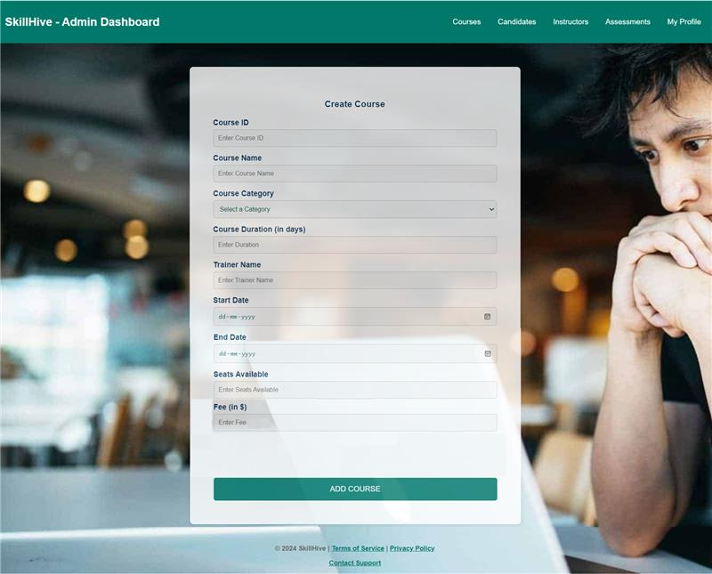**Screenshot 2.2:** View upcoming course(s) as Admin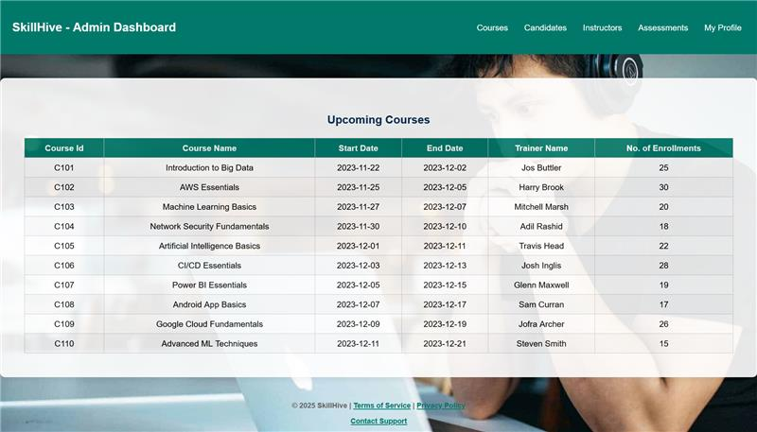

**Screenshot 2.3**: Course(s) deletion as Admin

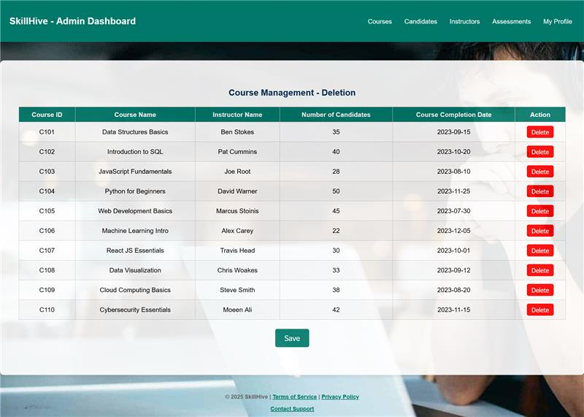

#### **3. Instructor Management**

**Purpose:** Maintain detailed information about instructors and their roles.

**Admin Features:**

* Add, update, or delete instructor records.
* Filter instructors by technology, rating.
* View all instructors.

**Instructor Features:**

* View assigned courses, view all instructors, and filter them by technology.

**Candidate Features:**

* View instructor profile for enrolled courses.

**Screenshot 3.1:** View all instructors as Admin

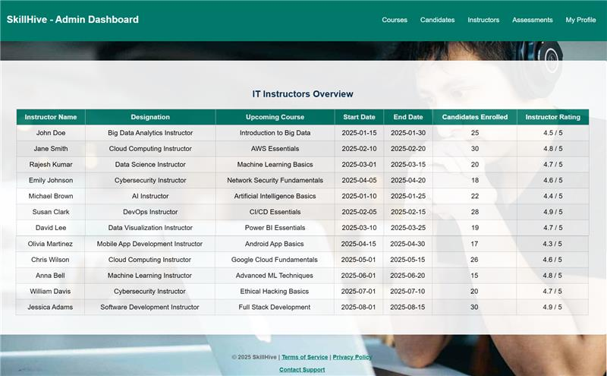

#### **4. Candidate Management**

**Purpose:** Facilitate candidate registration, profile management, and course tracking.

**Admin Features:**

* View all candidates, and filter them by course, and technology.
* Manage candidate profiles (delete).

**Instructor Features:**

* View all enrolled candidates (for the course for which he/she is an instructor)

**Candidate Features:**

* Self-register via "Enroll Now."
* Update personal profile details.

**Screenshot 4.1:** Home page displayed to the candidate before enrolling

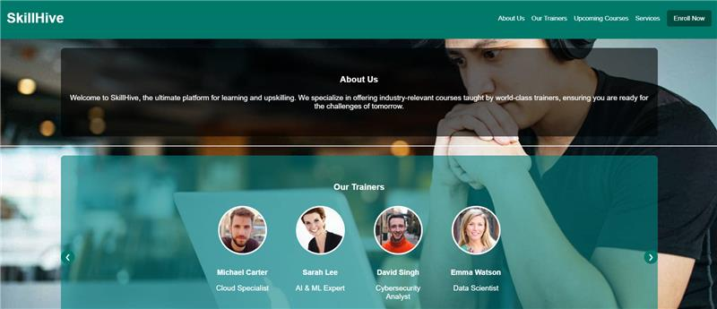

#### **5. Assessment and Grading**

**Purpose:** Schedule, administer, and grade assessments for courses.

**Admin Features:**

* Schedule assessment date for each course (default: 4 days post-course completion).

**Instructor Features:**

* Create data for MCQs (questions, choices, correct answer) and display the same in the UI page.
* Score calculation.

**Candidate Features:**

* Attempt MCQ assessments.
* Submit assessments and view score on submission.

**Screenshot 5.1:** MCQ attempt by candidate

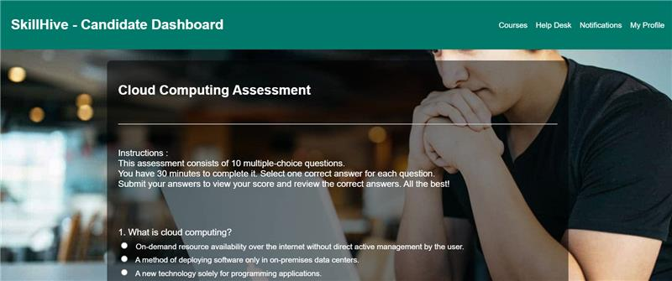

**Screenshot 5.2:** MCQ submission by candidate

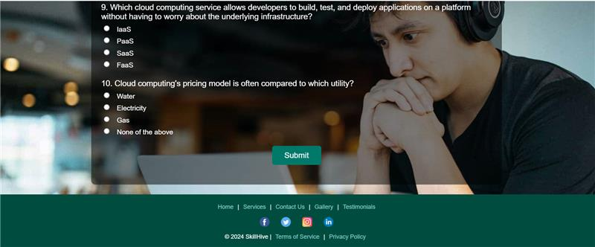

#### **6. Helpdesk System**

**Purpose:** Resolve issues and answer queries through a ticket-based system.

**Candidate Features:**

* Raise tickets for queries or technical issues.
* Track / view by ticket status and view all raised tickets with replies.

**Instructor Features:**

* Respond to candidate tickets.

**Admin Features:**

* View all tickets, view tickets by status, view tickets by course.

**Screenshot 6.1:** Ticket viewing and response page

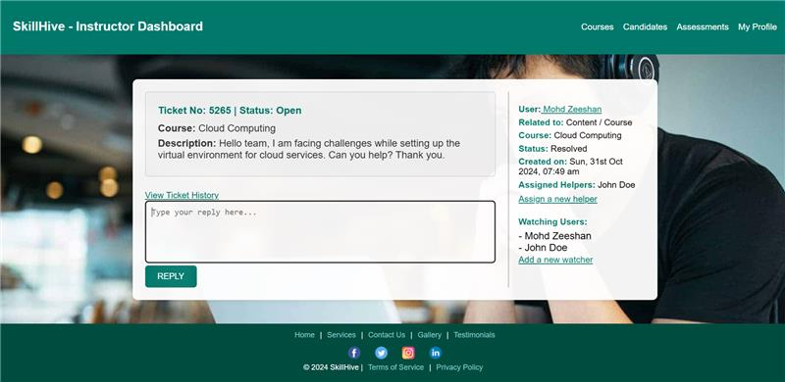

### **Artifacts to be delivered during the Project Phase**

* + Objectives and Business Scope
  + Project Team
  + UI Wireframe
  + Mock server Dataset

### **Technology Stack**

|  |  |
| --- | --- |
| **Component** | **Technology** |
| Framework | Angular |
| Backend | Mock JSON API Server |

### **Software** **Requirements**:

* + Angular v17
  + Node v20 and above
  + npm v10.2.3 and above
  + VS Code IDE

### **Project Milestones and Tasks:**

|  |  |  |
| --- | --- | --- |
| **Milestone** | **Weeks** | **Expected Task Completion** |
| 1 | Week 1 & 2 | Artifacts |
| 2 | Week 3 & 4 | Back-end module implementation |
| 3 | Week 5 & 6 | Front-end module implementation |
| 5 | Week 7 & 8 | Project Integration |

**Note**: The attached sample wireframes are provided for reference only, and not all screens are included. You are encouraged to incorporate your creativity and innovation into the design.